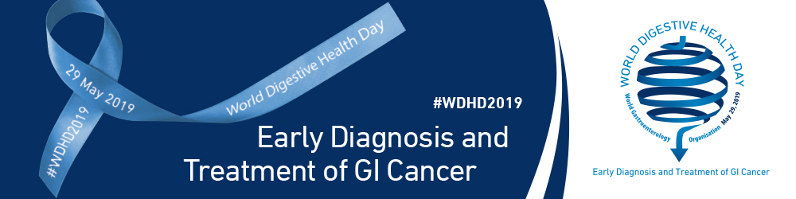
SAMPLE PRESS RELEASE

Contact:
[CONTACT NAME]
[CONTACT ORGANIZATION]
[PHONE]
[EMAIL]

[INSERT ORGANIZATION NAME] Celebrates World Digestive Health Day, #WDHD2019, by [INSERT CAMPAIGN DETAILS]

[INSERT LOCATION] [INSERT DATELINE] – This World Digestive Health Day (WDHD), [INSERT ORGANIZATION NAME] will support WDHD by [INSERT TOP LINE DETAIL OF CAMPAIGN].

World Digestive Health Day (WDHD) focuses yearly upon a particular digestive disease or disorder in order to increase general public awareness of prevention, prevalence, diagnosis, management, and treatment of the disease or disorder worldwide. This year the focus of WDHD is on the Early Diagnosis and Treatment of Gastrointestinal Cancer. WDHD is a global day of awareness that harnesses the collective power of individuals, organizations, and partners to improve digestive health worldwide.

[MORE DETAILED INFORMATION ON WHY YOUR ORGANIZATION IS PARTICIPATING IN WDHD 2019 AND DETAILS OF YOUR WDHD 2019 INITIATIVE INCLUDING GOALS, PARTNERS, AND PAST WDHD CAMPAGIN SUCCESS, IF APPLICABLE]

[INSERT QUOTE FROM YOUR ORGANIZATION’S SPOKESPERSON]

Founded in 2005 by the World Gastroenterology Organisation – a federation of over 110 gastroenterology related membership societies and associations representing over 50,000 individual members worldwide – World Digestive Health Day raises awareness of digestive health issues worldwide with the aim of reducing the global healthcare burden.

Those who are interested in joining [INSERT ORGANIZATION NAME]’s WDHD 2019 initiative can visit [INSERT SPECIFIC WDHD CAMPAIGN LANDING PAGE ADDRESS IF AVAILABLE]. For more details about the WDHD 2019 campaign, visit the WDHD 2019 website (www.worldgastroenterology.org/wgo-foundation/wdhd/wdhd-2019), Facebook page (www.facebook.com/WGOFWDHD), or follow @WGOF_WDHD and the #WDHD2019 hashtag on Twitter.

About [INSERT ORGANIZATION NAME]
[INSERT ORGANIZATION BOILER PLATE]

About World Digestive Health Day

The first World Digestive Health Day (WDHD) was held on 29 May 2005. Ever since the World Gastroenterology Organisation (WGO), in collaboration with The WGO Foundation (WGOF), annually celebrates World Digestive Health Day by initiating a yearlong, worldwide, public health campaign through more than 110 WGO Member Societies which reach over 50,000 individuals worldwide, WGO Training Centers, Regional Affiliate Associations, and other WGO global partners. Each year focuses upon a particular digestive disease or disorder in order to increase general public awareness of prevention, prevalence, diagnosis, management, and treatment of the disease or disorder.

To learn more about World Digestive Health Day activities or to join the celebration, please visit:
Website: www.worldgastroenterology.org/wgo-foundation/wdhd/wdhd-2019
Facebook: www.facebook.com/WGOFWDHD
Twitter: twitter.com/WGOF_WDHD

